….continued

Test - 1
- >gradle test
- 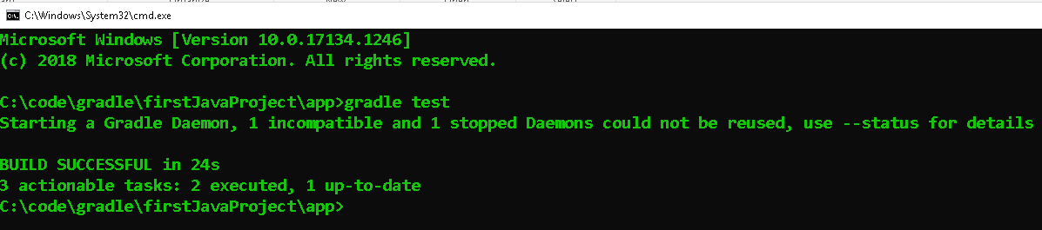
- How to verify? Open
- Go to C:\code\gradle\firstJavaProject\app\build\reports\tests\test and open index.html file
- It will show successful
- 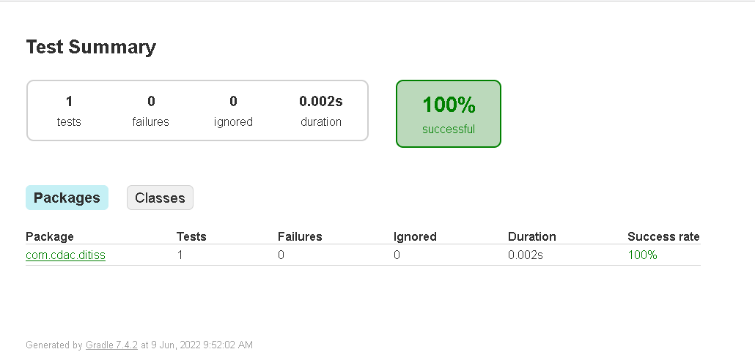
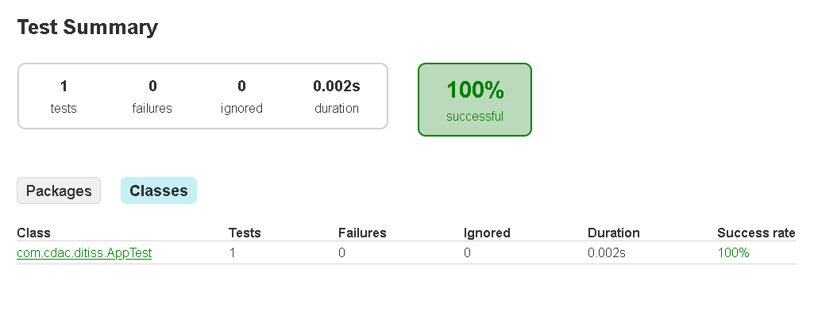
—-------------------------------------------------------------------------------
TEST FAIL

  - If you want to fail the test then open App.java and change in the method and return null or any number as it returns the string.
  - Open file App.java at this location C:\code\gradle\firstJavaProject\app\src\main\java\com\cdac\ditiss
  - Original file
  - 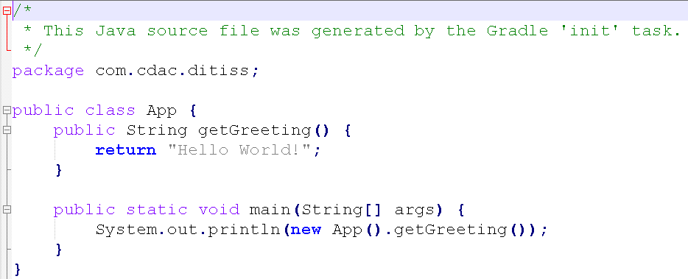

  - Modified file
  - 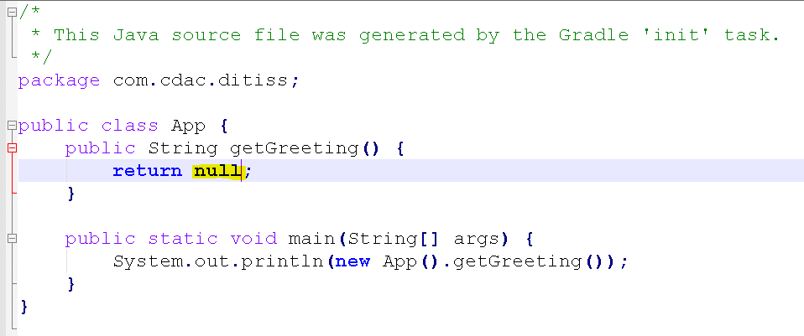
- Use same cmd >gradle test
- 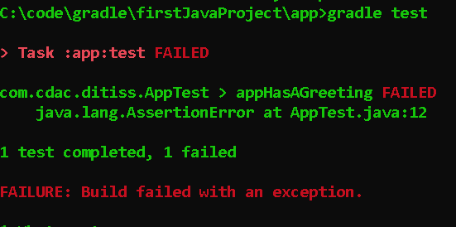
- Go to C:\code\gradle\firstJavaProject\app\build\reports\tests\test and open index.html file
- It will show Failed
- 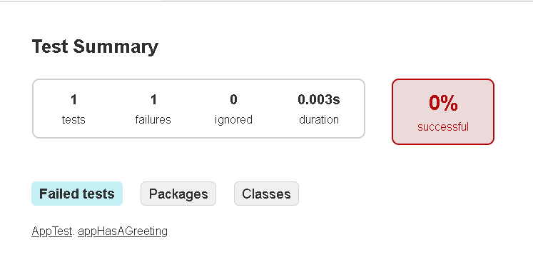
—-------------------------------------------------------------------------------

What is JAR file?
- A file with the .JAR file extension is a Java Archive file used for storing Java programs and games in a single file. Some contain files that make them work as standalone apps, and others hold program libraries for other programs to use.
- JAR files are ZIP compressed and often store things like CLASS files, a manifest file, and application resources like images, sound clips, and security certificates. Since they can hold hundreds or even thousands of files in a compressed format, it's easy to share and move them.
  - JAR file will only run on cmd prompt
E.g.
Account.java ⇒ Account.class ===>
Loan.java ⇒ Loan.class ===> zipfile bank.JAR
Card.java ⇒ Card.class ===>
—-------------------------------------------------------------------------------
What is WAR file?
- A WAR file is a compressed package containing Java-based web components and applications that are run on a web server. It is formatted the same way as a .JAR file, but includes additional information that tells the application server which Java servlet class to run.
- WAR file will only run on Web Server (tomcat)
—-------------------------------------------------------------------------------
Dependencies in build.gradle file

The libraries our code needs to compile and execute the project
implementation 'com.google.guava:guava:30.1.1-jre
Says that gradle will use this JRE - so if this statement is missing, gradle will try to use the default JRE installed on your computer
Three parts, separated by colon → com.google.guava:guava:30.1.1-jre
—-------------------------------------------------------------------------------
Search in google> junit maven library >https://mvnrepository.com/artifact/junit/junit

Click on latest version 4.13.2> gradle>
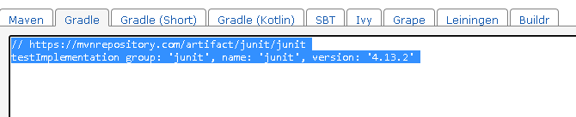 >copy and paste it in build.gradle in dependencies class
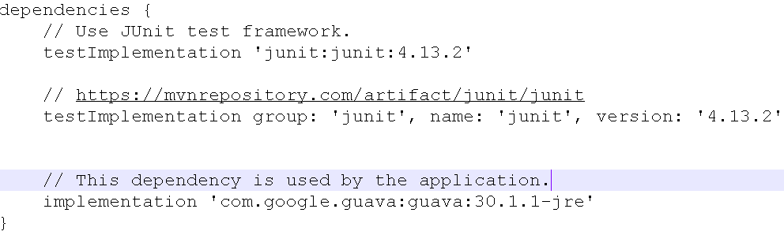
Now on Cmd
>gradle test
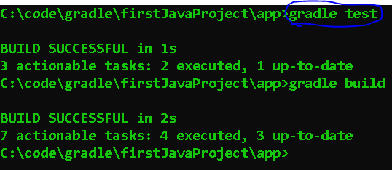
>gradle jar
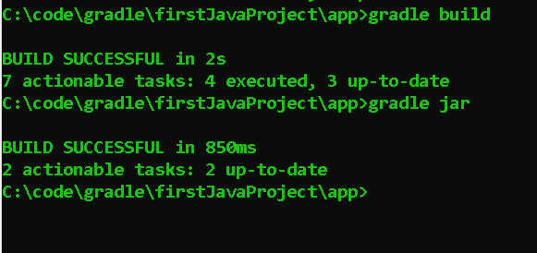
Go to C:\code\gradle\firstJavaProject\app\build\libs you will see app.jar file is created
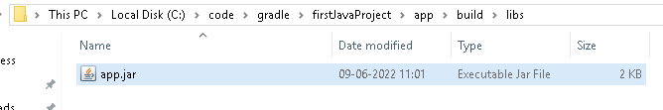

—-------------------------------------------------------------------------------

Type of dependencies in gradle
- Implementation : Available for compiling and running the code
- testImplementation: Available for compiling and running the testing code
- compileOnly : Available during compilation only, not during run time.
- runtimeOnly : Available during execution only.
- Similarly, we have testCompileOnly and testRuntimeOnly
—-------------------------------------------------------------------------------
Build a Web Application using GRADLE

Application flow

index.html(Ask the user to click on a link called as Get Coupon) ⇒ CouponServlet.java(Show the coupon code to the user) ⇒ user needs to copy the coupon code

Index.html
(Ask the user to click on a link called as Get Coupon)
CouponServlet.java
(Show the coupon code to the user)
user needs to copy the coupon code

—------------------------------------------------------------------------------
Creating the folder
- Create a folder firstWebApp inside C:\code\gradle using cmd mkdir firstWebApp
- 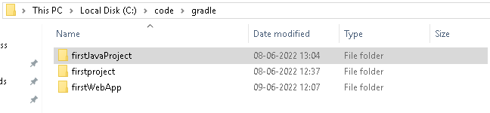
- Run gradle init inside the folders command prompt
C:\code\gradle\firstWebApp>gradle init
- Select 2,3,1,1, no 1, firstWebApp, com.cdac.ditiss
—------------------------------------------------------------------------------
Folder changes - 1
Rename the app file to firstWebApp
Note: under ditiss folder delete App.java

—------------------------------------------------------------------------------

Folder Changes -1

Create a folder webapp under main(java,resources,webapp)
C:\code\gradle\firstWebApp\firstWebApp\src\main

—------------------------------------------------------------------------------
Create Servlet skeleton
(C:\code\gradle\firstWebApp\firstWebApp\src\main\java\com\cdac\ditiss\CouponServlet.java)

package com.cdac.ditiss;

import java.io.IOException;
import java.io.PrintWriter;
import javax.servlet.ServletException;
import javax.servlet.annotation.WebServlet;
import javax.servlet.http.HttpServlet;
import javax.servlet.http.HttpServletRequest;
import javax.servlet.http.HttpServletResponse;

public class CouponServlet extends HttpServlet {
protected void doGet(HttpServletRequest request, HttpServletResponse response)
throws ServletException, IOException {
}
}
—-----------------------------------------------------------------------------------
Create index.html inside
C:\code\gradle\firstWebApp\firstWebApp\src\main\webapp
Open browser paste URL
https://www.tutorialspoint.com/online_html_editor.php

<!DOCTYPE html>
<html>
<title>Online HTML Editor</title>
<head>
</head>
<body>
<h1>Welcome to CDAC ACTS</h1>
<a href="coupon">Get Coupon</a>
<form method = "post" action = "coupon">
Coupon Code: <input type = "text" name = "coupon">
<input type = "submit" value = "Get Discount">
</form>
</body>
</html>
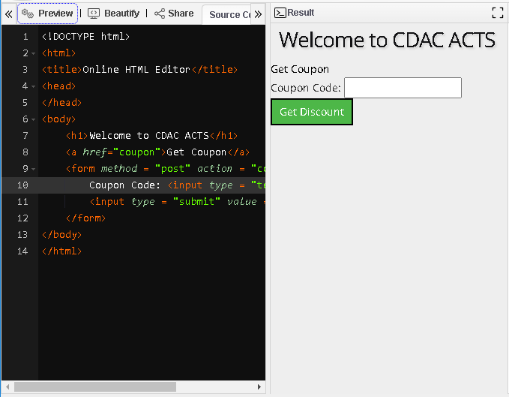
—------------------------------------------------------------------------------------------
Go to
C:\code\gradle\firstWebApp
Edit settings file
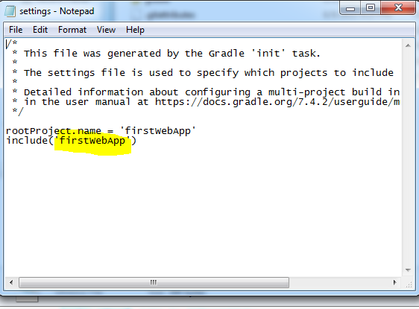

Make changes in the CouponServlet.java file and add 2 entries as we will add a function i.e Get Coupon button should work

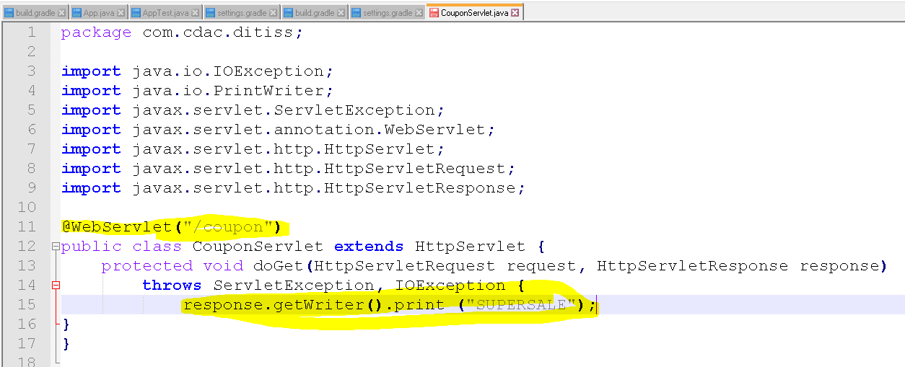

—-------------------------------------------------------------------------------------Now open build.gradle file
Remove all dependencies
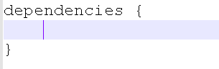

—-------------------------------------------------------------------------------------
Go to mvnrepository.com >search Java Servlet API>Central>4.0.0
// https://mvnrepository.com/artifact/javax.servlet/javax.servlet-api

And paste in build.gradle file under dependencies
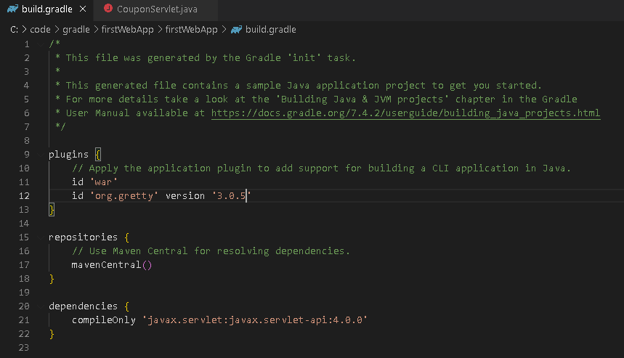
OR
/*
* This file was generated by the Gradle 'init' task.
*
* This generated file contains a sample Java application project to get you started.
* For more details take a look at the 'Building Java & JVM projects' chapter in the Gradle
* User Manual available at https://docs.gradle.org/7.4.2/userguide/building_java_projects.html
*/

plugins {
// Apply the application plugin to add support for building a CLI application in Java.
id 'war'
id 'org.gretty' version '3.0.5'
}

repositories {
// Use Maven Central for resolving dependencies.
mavenCentral()
}

dependencies {
compileOnly 'javax.servlet:javax.servlet-api:4.0.0'
}

Edit CouponServlet
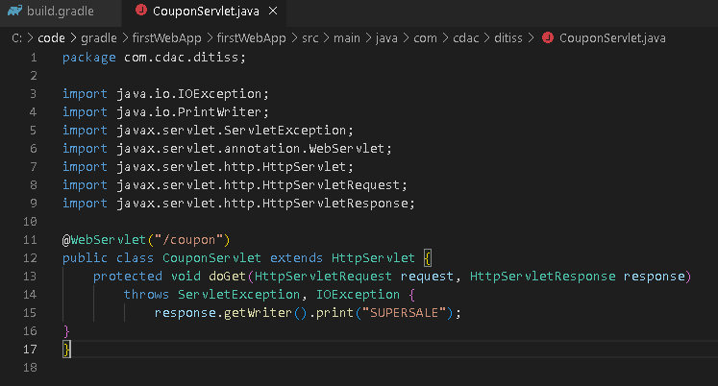
OR
package com.cdac.ditiss;

import java.io.IOException;
import java.io.PrintWriter;
import javax.servlet.ServletException;
import javax.servlet.annotation.WebServlet;
import javax.servlet.http.HttpServlet;
import javax.servlet.http.HttpServletRequest;
import javax.servlet.http.HttpServletResponse;

@WebServlet("/coupon")
public class CouponServlet extends HttpServlet {
protected void doGet(HttpServletRequest request, HttpServletResponse response)
throws ServletException, IOException {
response.getWriter().print("SUPERSALE");
}
}

—-------------------------------------------------------------------------------------

C:\code\gradle\firstWebApp
On cmd under > gradle war
Cmd > gradle appRun
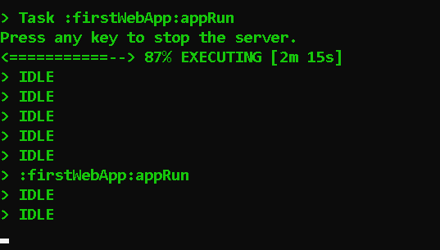
Open in browser
http://localhost:8080/firstWebApp/

